Command for updating it:

db.books.updateOne( { ISBN:"999-888"},

{ $set: { Author:"Simon Collins"},

$currentDate: { lastModified: true }

} )

(used updateone here as only one instance of ISBN: 999-888 was present in the collection)

screenshot:

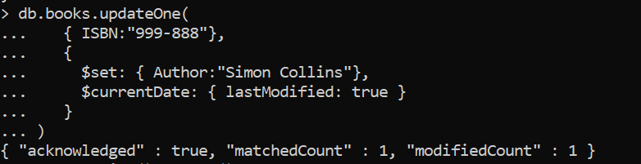

To show how it looks like actually in storage, the find() command can be run along with pretty()

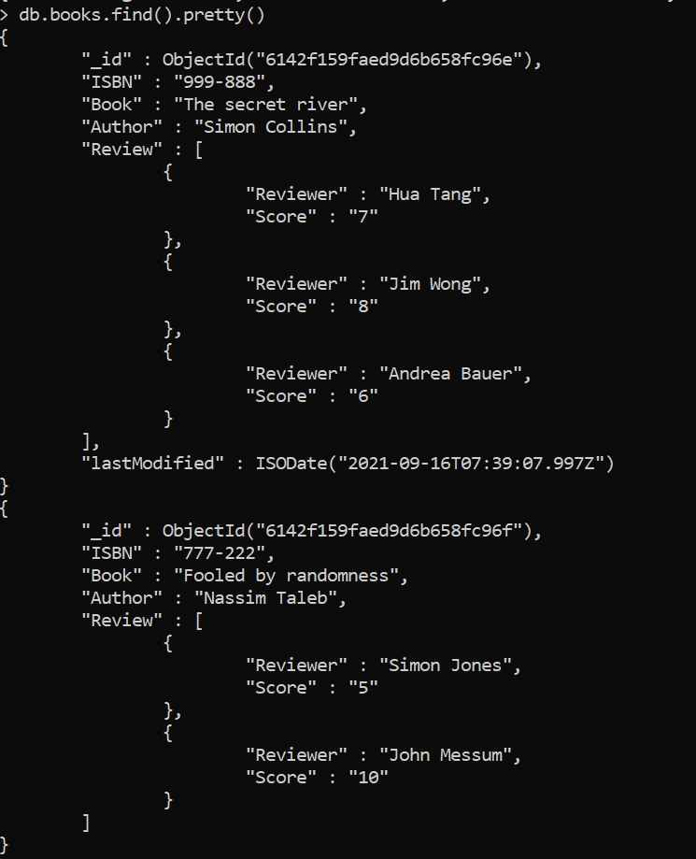

Upsert:

MongoDB upsert option is used with **update method which creates a new document if** the query does not retrieve any documents satisfying the criteria. The default value for this option is false. The upsert option does an insert based on the field and value pairs specified in the update parameter or field and value pairs specified in both query and update parameter.

(ref: [MongoDB upsert example using Mongo Shell and Java Driver - JournalDev](https://www.journaldev.com/6324/mongodb-upsert-example-using-mongo-shell-and-java-driver))

Basically, it is like update, except here, if there isn’t any match found, it will work like an insert instead and thus will just add the new document to the collection (instead of updating any document).